**Keang Cheang Ung**

keangcheang@gmail.com

979-250-2429

**Feature Selection Modeling for Predicting House Price in Nashville**

Springboard Capstone Project 1

### **Problem and Objective**

Real estate in the US has been an interesting topic for not only developers or investors but also to academic researchers or data enthusiast who wants to understand more about how to predict the house price. In this project, we will focus on the real estate in Nashville where the markets trends indicated an increase of $19,000 about 7% in median home sale over the past year. The average price per square foot for this same period rose to $195, up from $180.

The objective of this project was to determine the features that affects house price in Nashville using linear regression with regularization. In order to achieve this, we had to take several procedures like collecting and preparing the data set ready for modeling. Visualization for this project was essential to find the insight from different features against price. We trained the data set for modeling and test it with the tested data set. During this process, we also had to use regularization like Lasso for feature selections.

### **Data Wrangling and Visualization**

With regard to the capstone project which is about feature selections of important attributes that determine house price in Nashville, there were some data wrangling techniques used to prepare the data and ready for modeling.

First of all, checking the format of each feature regarding their datatypes and their observation sizes was my first step. This way I would know if there should be any datatype conversions I should take or any missing values I had to tackle. In this dataset, there were 56,000+ observations with 29 variables and 31 columns (List of features shown in Table 1). There were several features that contained missing values such as the exterior wall, tax district …etc. The house price attribute was numeric as well as land value, building value and total value which were essential to this project.

Table 1: List of Features

|  |  |
| --- | --- |
| **Features** | **Type** |
| Sale Price | Numeric |
| Legal Reference | String |
| Sold as Vacant | String |
| Multiple Parcels Involved in Sale | String |
| Owner Name | String |
| Address | String |
| City | String |
| State | String |
| Acreage | Numeric |
| Tax District | String |
| Neighborhood | Numeric |
| image | String |
| Land Value | Numeric |
| Building Value | Numeric |
| Total Value | Numeric |
| Finished Area | Numeric |
| Foundation Type | String |
| Year Built | Numeric |
| Exterior Wall | String |
| Grade | String |
| Bedrooms | Numeric |
| Full Bath | Numeric |
| Half Bath | Numeric |

Next, I had to check the distribution of price variable whether it was a normal distribution and make correction according to that. The result showed that the price is not normally distributed (Figure 1) and it was hard to interpret, thus I took the log transformation of the price variable so it can be interpretable and became a bell-shaped distribution with a little of skewness to the left. This indicated that some houses were sold higher than the average price which was logical and rational to the current housing market in Nashville. Moreover, total value, land value and building value were also converted to log value so that I could plot them against price in order to check their correlations (Figure 1). Like expected, they all had a positive relationship with price. In addition to this, I also made a heat-map with the correlation matrix to delve more into their relationship with price as shown in Figure 2. Land value, total value, finished value and full bath had moderate correlations with price.

Figure 1: Log Sale Price Distribution and Scatter plot of Log Sale Price and Log Total Value

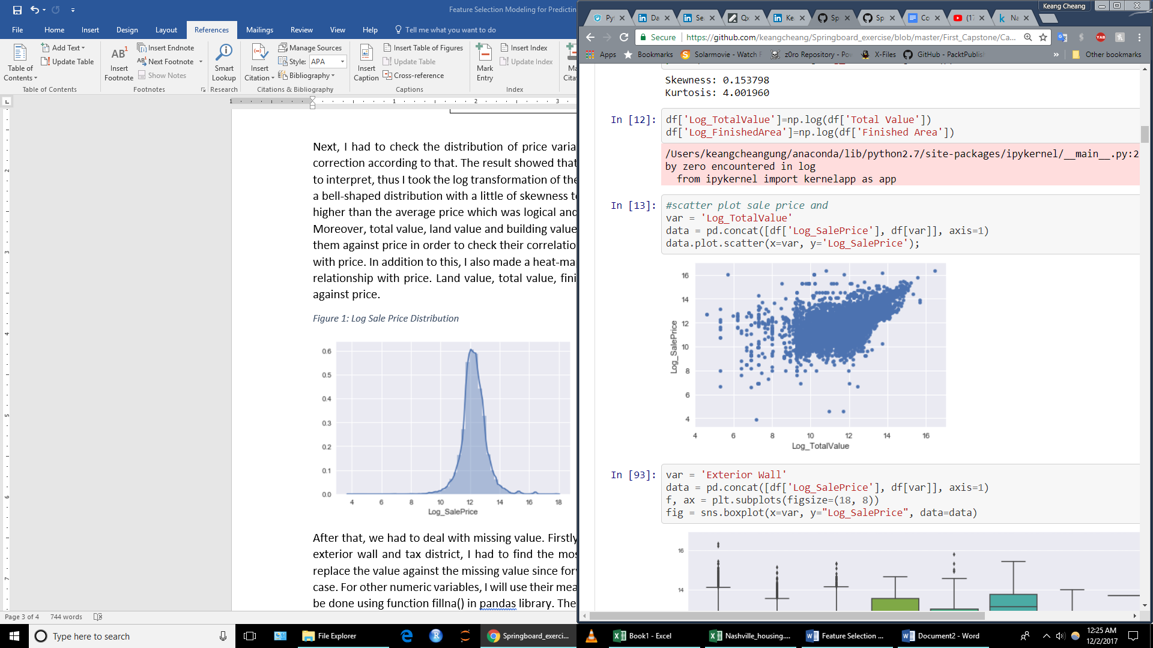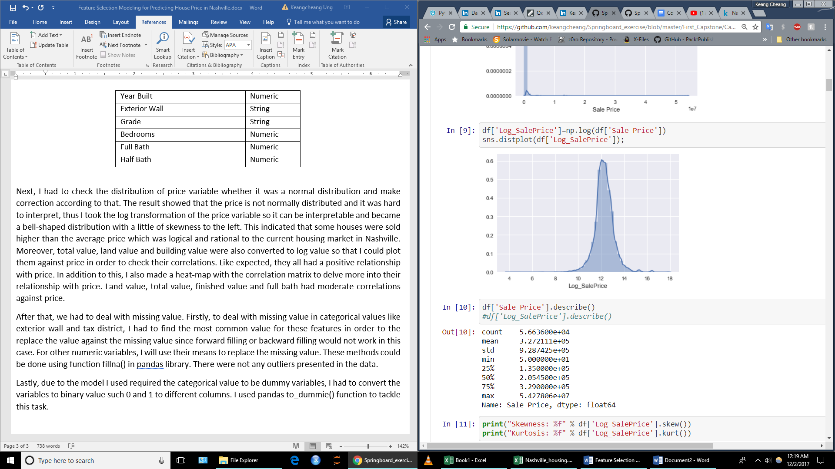

Figure 2: Heatmap with Correlation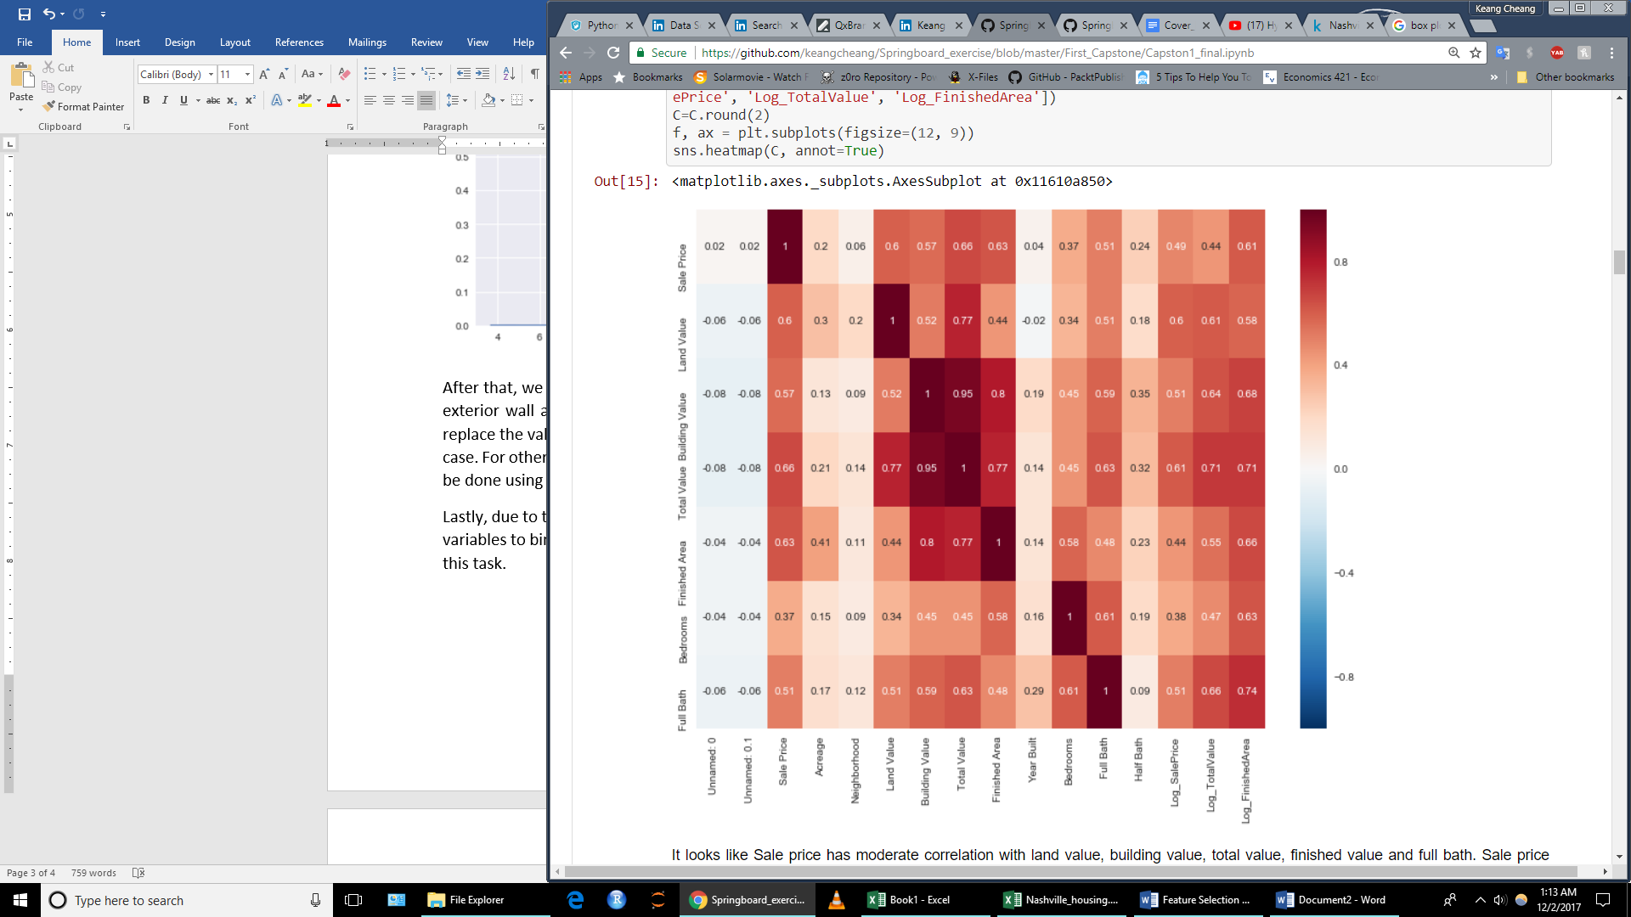

After that, we had to deal with missing value. Firstly, to deal with missing value in categorical values like exterior wall and tax district, I had to find the most common value for these features in order to the replace the value against the missing value since forward filling or backward filling would not work in this case. For other numeric variables, I will use their means to replace the missing value. These methods could be done using function fillna() in pandas library. There were not any outliers presented in the data.

Lastly, due to the model I used required the categorical value to be dummy variables, I had to convert the variables to binary value such 0 and 1 to different columns. I used pandas to_dummie() function to tackle this task.

**Modeling and Result**

Training and testing set sizes (21131, 32) (9056, 32)

The median house price: $ 204000

The mean house price: $ 272849

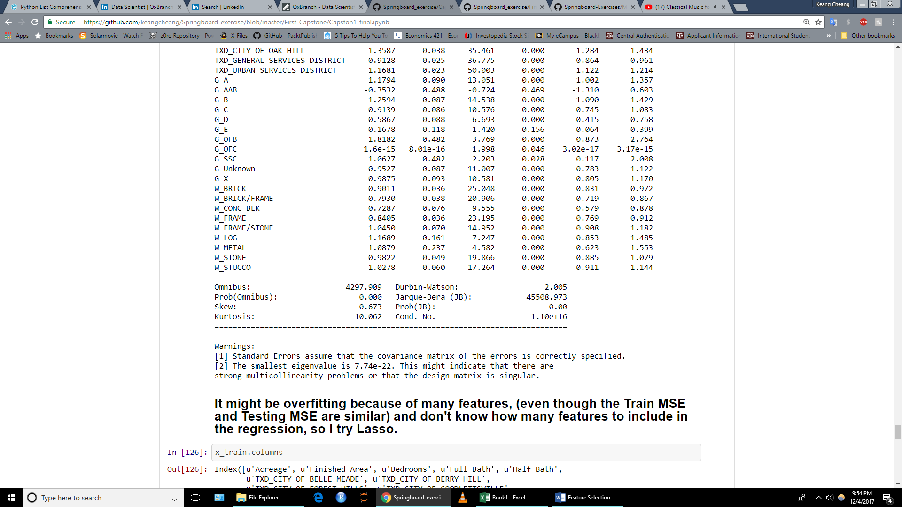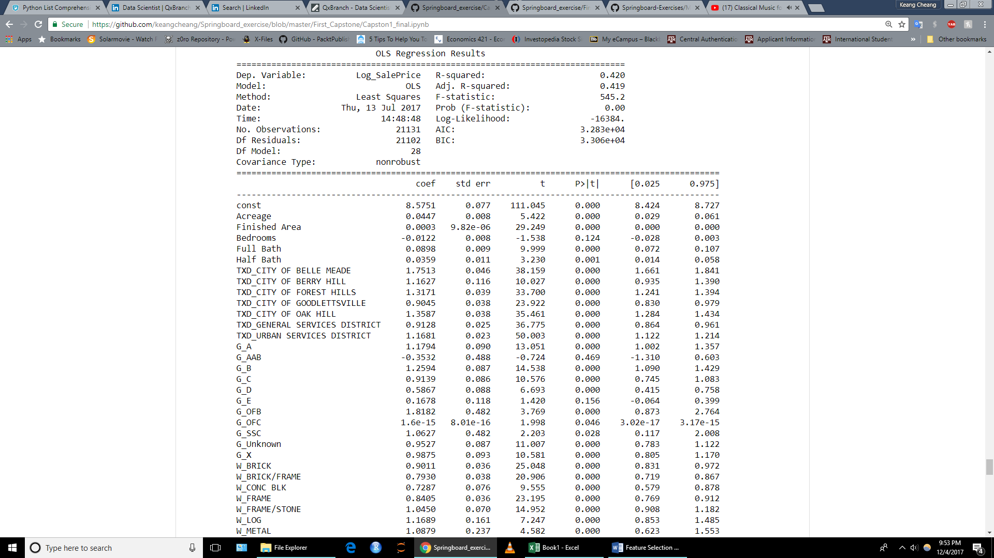

Testing Score: 0.411476963149

Training MSE: 0.276040455527

Testing MSE: 0.269870736571

### Conclusion

### Reference

* <https://www.trulia.com/real_estate/Nashville-Tennessee/market-trends>
* https://www.kaggle.com/tmthyjames/nashville-housing-date